Software Requirements Specification for Annapurna
Version 1.0
Prepared by Project Team 30

Name | PRN
Amol Gavit | 250240320013
Meenakshi Lokhande | 250240320061
Shilpa Pandey | 250240520079
Pallavi Sahay | 250240320072
Suchi Tripathi | 250240320117

Centre for Development of Advanced Computing

Raintree Marg, Near Bharati Vidyapeeth, Opp. Kharghar Railway Station, Sector 7, CBD Belapur, Navi Mumbai - 400 614 - Maharashtra (India)
Phone: +91-22-27565303
Fax: +91-22-2756-0004

Contents
- Introduction 2
  - Purpose . . . . . . . . . . . . . . . . . . . . . . . . . . . . . . . . . . . . 2
  - Document Conventions . . . . . . . . . . . . . . . . . . . . . . . . . . . . 2
  - Intended Audience and Reading Suggestions . . . . . . . . . . . . . . . . 2
  - Project Scope . . . . . . . . . . . . . . . . . . . . . . . . . . . . . . . . . 2
  - References . . . . . . . . . . . . . . . . . . . . . . . . . . . . . . . . . . . 2
- Overall Description 3
  - Product Perspective . . . . . . . . . . . . . . . . . . . . . . . . . . . . . 3
  - Product Features . . . . . . . . . . . . . . . . . . . . . . . . . . . . . . . 3
  - User Classes and Characteristics . . . . . . . . . . . . . . . . . . . . . . . 3
  - Operating Environment . . . . . . . . . . . . . . . . . . . . . . . . . . . 3
  - Design and Implementation Constraints . . . . . . . . . . . . . . . . . . 4
  - User Documentation . . . . . . . . . . . . . . . . . . . . . . . . . . . . . 4
  - Assumptions and Dependencies . . . . . . . . . . . . . . . . . . . . . . . 4
- System Features 4
  - Customer Functionalities . . . . . . . . . . . . . . . . . . . . . . . . . . . 4
    - Description and Priority . . . . . . . . . . . . . . . . . . . . . . . 4
    - Stimulus/Response Sequences . . . . . . . . . . . . . . . . . . . . 4
    - Functional Requirements . . . . . . . . . . . . . . . . . . . . . . . 4
  - Vendor Functionalities . . . . . . . . . . . . . . . . . . . . . . . . . . . . 5
    - Description and Priority . . . . . . . . . . . . . . . . . . . . . . . 5
    - Stimulus/Response Sequences . . . . . . . . . . . . . . . . . . . . 5
    - Functional Requirements . . . . . . . . . . . . . . . . . . . . . . . 5
  - Admin Functionalities . . . . . . . . . . . . . . . . . . . . . . . . . . . . 5
    - Description and Priority . . . . . . . . . . . . . . . . . . . . . . . 5
    - Stimulus/Response Sequences . . . . . . . . . . . . . . . . . . . . 5
    - Functional Requirements . . . . . . . . . . . . . . . . . . . . . . . 5
- External Interface Requirements 6
  - User Interfaces . . . . . . . . . . . . . . . . . . . . . . . . . . . . . . . . 6
  - Hardware Interfaces . . . . . . . . . . . . . . . . . . . . . . . . . . . . . 6
  - Software Interfaces . . . . . . . . . . . . . . . . . . . . . . . . . . . . . . 6
  - Communications Interfaces . . . . . . . . . . . . . . . . . . . . . . . . . . 6
- Other Nonfunctional Requirements 6
  - Performance Requirements . . . . . . . . . . . . . . . . . . . . . . . . . . 6
  - Safety Requirements . . . . . . . . . . . . . . . . . . . . . . . . . . . . . 6
  - Security Requirements . . . . . . . . . . . . . . . . . . . . . . . . . . . . 7
  - Software Quality Attributes . . . . . . . . . . . . . . . . . . . . . . . . . 7

6 Other Requirements

Introduction

Purpose
This Software Requirements Specification (SRS) outlines the requirements for Annapurna, an online tiﬀin service platform connecting home-based food vendors with customers, including students and oﬀice workers. The goal is to provide healthy, homemade food and a way for vendors to earn from home. Version 1.0 covers the core modules for Customer, Vendor, and Admin.

Document Conventions
- Follows the IEEE SRS template.
- A Glossary is provided in Appendix A for technical terms.

Intended Audience and Reading Suggestions
This document is intended for:
- Developers: For development reference.
- Testers: For creating test cases.
- Stakeholders: To validate functionality.
- Trainers & Documentation Writers: For preparing training materials.

Project Scope
The platform enables:
- Customers to view, order, and pay for tiﬀin services.
- Vendors to maintain tiﬀin plans and track sales.
- Admins to approve vendors, monitor activity, and handle payments/disputes. It supports real-time dashboards and secure access for all users.

References
- https://reactjs.org/docs
- https://spring.io
- https://hibernate.org

Overall Description

Product Perspective
Annapurna is a web-based platform comprising:
- Frontend React.
- Spring Boot and ASP.NET REST backend.
- MySQL and MS SQL Server database.
It can run standalone or be scaled to cloud. It is not part of another system.

Product Features
- Customer and Vendor registration.
- Tiﬀin plans with search/filter functionality.
- Secure order and payment processing.
- Order history and reviews.
- Vendor dashboard.
- Admin analytics panel.
- Role-based access control.

User Classes and Characteristics
- Anonymous: Browse menu.
- Customer: Order, review, pay.
- Vendor: Manage menu, view sales.
- Admin: Full access and analytics.

Operating Environment
- Web browsers: Chrome, Firefox, Edge.
- Frontend: ReactJS.
- Backend: Spring Boot and ASP.NET.
- Database: MySQL and MS SQL Server.
- OS: Windows, Linux, or Cloud.

Design and Implementation Constraints
- Must use Java/Spring Boot and .NET.
- MySQL required.
- Role-based access control enforced.

User Documentation
- Online user guide.
- Admin manual (PDF).
- Tutorials and demo videos.
- FAQ section.

Assumptions and Dependencies
- Users have internet access.
- Third-party APIs (e.g., Payment Gateway) are available.
- Future versions may depend on location APIs.

System Features

Customer Functionalities
    - Description and Priority
Enables Customers to register, place orders, cancel within 5 minutes, pay online, and review orders.
Priority: High

    - Stimulus/Response Sequences
      - User registers → Confirmation email sent.
      - Places order → Payment triggered → Order placed.
      - Cancels within 5 minutes → Refund initiated.

    - Functional Requirements
- REQ-1: Customers must register and log in.
- REQ-2: Can browse tiﬀin menus and plans.
- REQ-3: Can place or cancel orders within 5 minutes.
- REQ-4: Can pay securely.
- REQ-5: View order history.
- REQ-6: Leave ratings/reviews.

Vendor Functionalities
    - Description and Priority
Enables Vendors to manage menu, accept/reject orders, track sales, and view feedback.
Priority: High

    - Stimulus/Response Sequences
      - Vendor logs in → Adds/updates tiﬀin items.
      - Order placed → Notification to vendor → Vendor accepts/rejects.

    - Functional Requirements
- REQ-7: Vendor registration and login.
- REQ-8: Manage menu items.
- REQ-9: View order analytics.
- REQ-10: Accept/reject orders.
- REQ-11: View customer reviews.

Admin Functionalities
    - Description and Priority
Enables Admins to approve vendors, monitor orders, payments, and disputes.
Priority: High

    - Stimulus/Response Sequences
      - Vendor registers → Admin approves.
      - Complaint raised → Admin investigates and resolves.

    - Functional Requirements
- REQ-12: Admin login.
- REQ-13: Approve vendors and tiﬀin listings.
- REQ-14: Track sales and transactions.
- REQ-15: Manage user accounts and disputes.

External Interface Requirements

User Interfaces
- Responsive UI using HTML, CSS, and Bootstrap.
- Login, dashboard, and menu management screens.
- Error and success alerts.
- Order tracking panel.

Hardware Interfaces
- No special hardware required.
- Standard browser with internet access.

Software Interfaces
- MySQL database.
- Payment gateway API (Razorpay or Stripe).
- SMTP server for emails.
- JWT-based authentication interface.

Communications Interfaces
- HTTPS for all communication.
- RESTful APIs using HTTP.
- Email for order confirmation and updates.
- Future: SMS/Push notifications.

Other Nonfunctional Requirements

Performance Requirements
- Support 100+ concurrent users.
- Response time < 2 seconds.
- Load balanced on server.

Safety Requirements
- Secure payment flow.
- Regular backups.
- Data recovery in case of crash.

Security Requirements
- JWT authentication.
- Role-based authorization.
- SSL encryption.
- Auto logout on inactivity.
- Encrypted passwords using BCrypt.

Software Quality Attributes
- Availability: 99.99% uptime.
- Reliability: Daily backups.
- Maintainability: Modular codebase.
- Portability: Deployable on any OS or cloud.
- Usability: Simple and responsive UI.

Other Requirements
- GDPR compliance for customer data.
- Multi-language support in future versions.

Vendor KYC verification.
- Graph/chart dashboard for analytics.

Appendix A: Glossary
- JWT: JSON Web Token.
- CRUD: Create, Read, Update, Delete.
- UI: User Interface.
- SSL: Secure Sockets Layer.
- DFD: Data Flow Diagram.
- KYC: Know Your Customer.

Appendix B: Analysis Models
- Use Case Diagrams: Admin, Vendor, Customer.

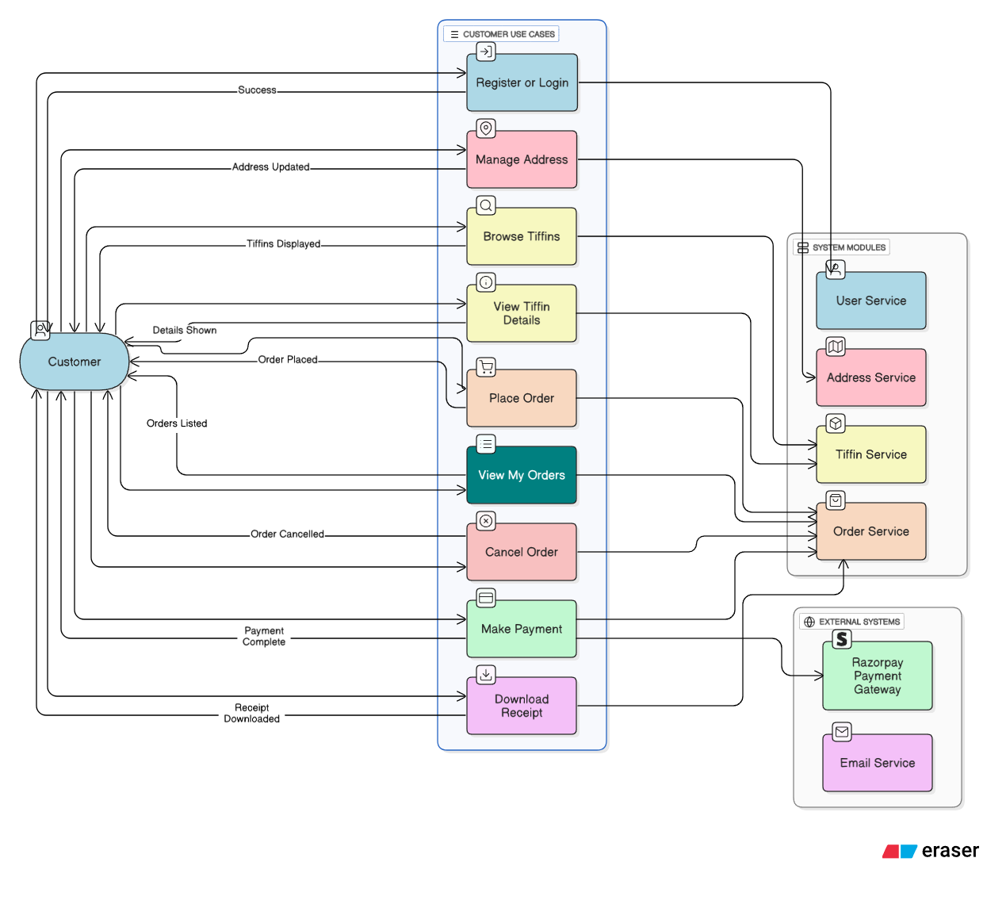

Use Case Diagram of Customer Activities

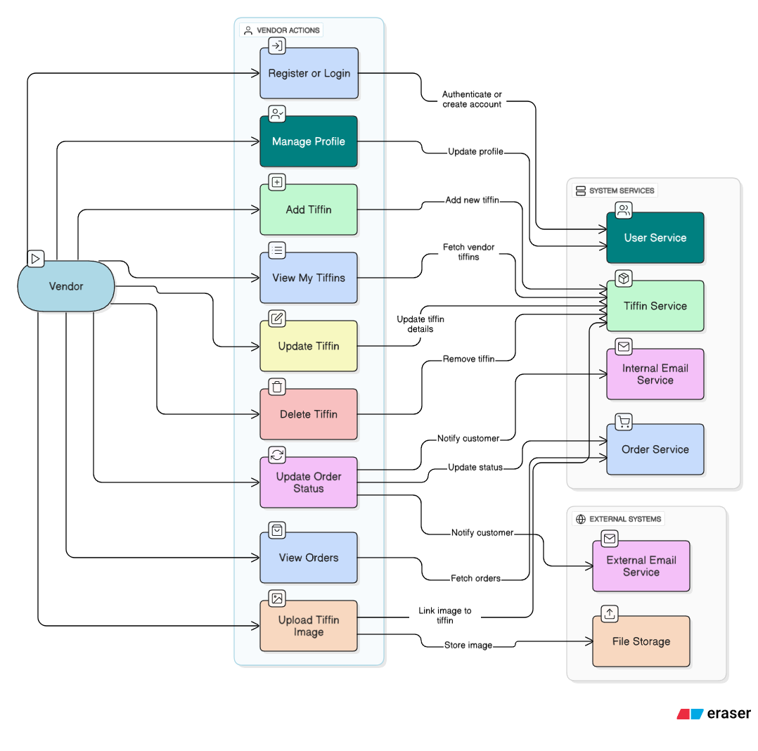

Use Case Diagram of Vendor Activities
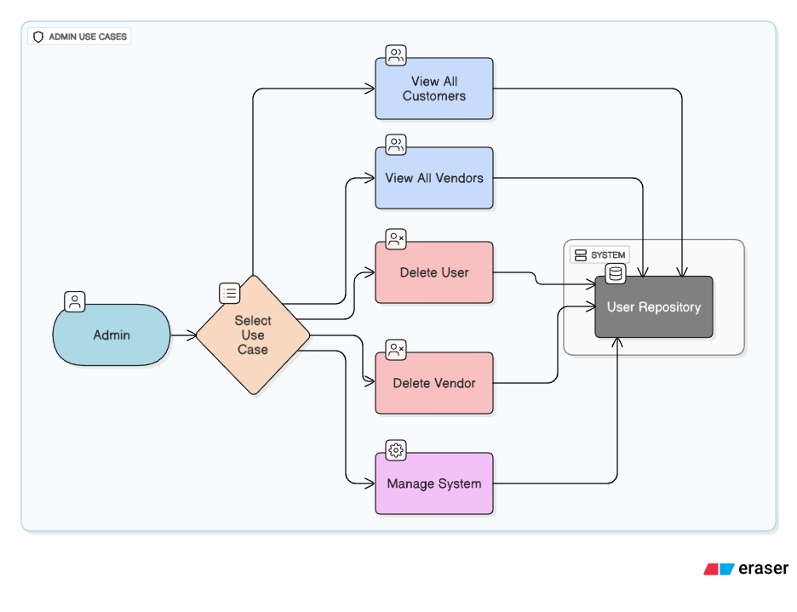

Use Case Diagram of Admin Activities

- Level-1 DFDs: Vendor, Customer, Admin.
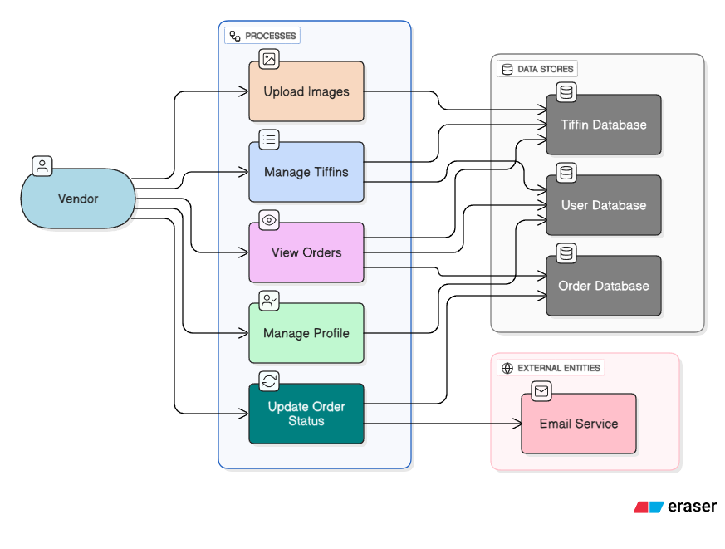

Level 1 DFD (Vendor)
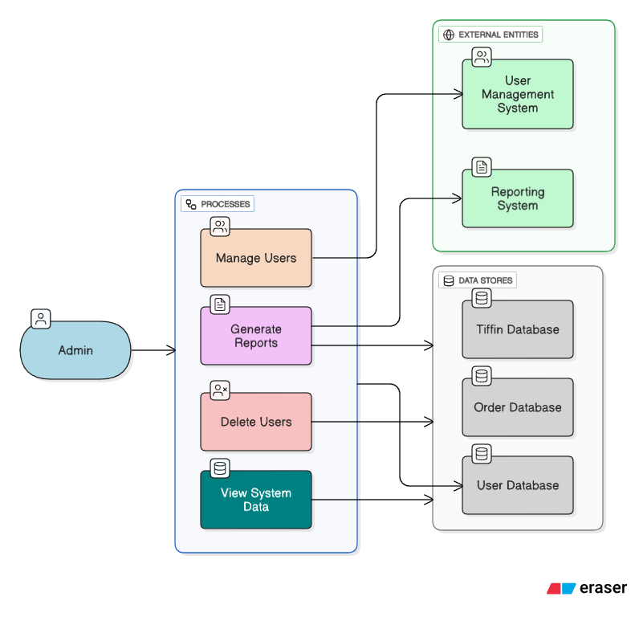

Level 1 DFD (Admin)

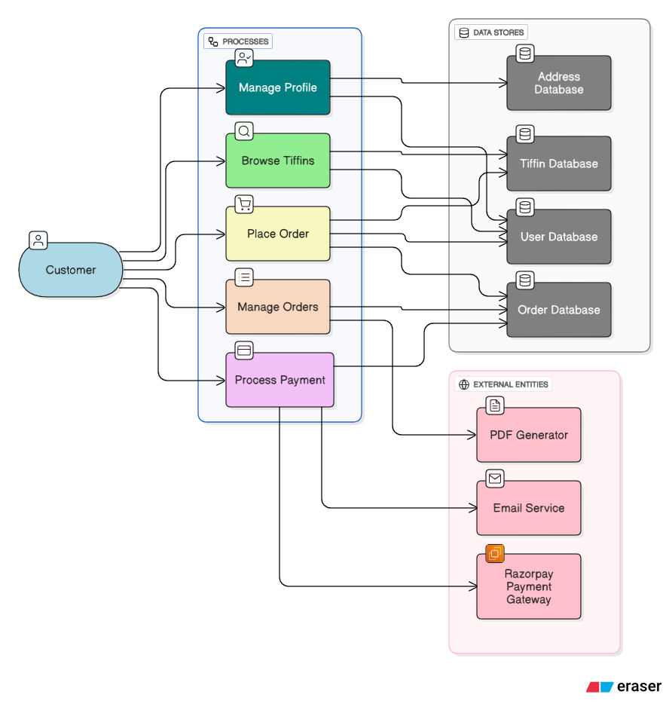

Level 1 DFD (Customer)

- ER Diagram: MySQL auto-generated.
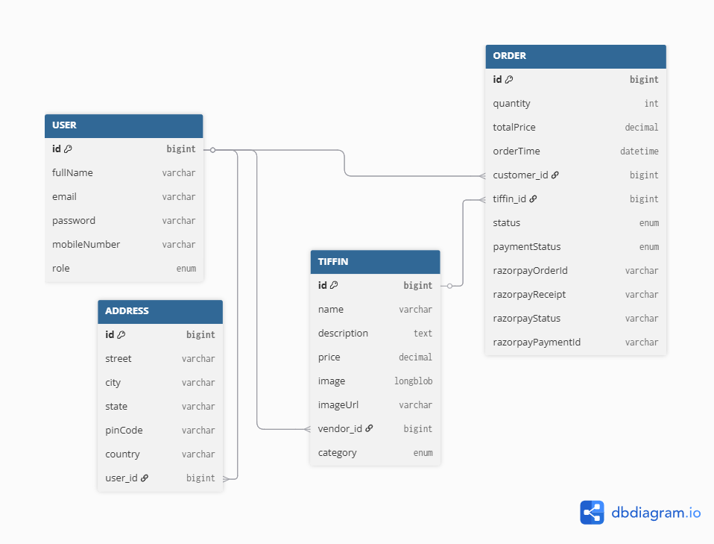

ER Diagram

